Peter Julius M. Estacio
Grouped with:
Niño Aloysius V. De Mesa
Christian James S. Madariaga
ENGG 151.01-A
February 11, 2026

Progress Report 3 for Project 1: Normalized Crosscorrelation

As of February 11, 2026, major progress has been made. Header implementation was used to compartmentalize validation of integers and doubles, signal file reading, and computing the normalized crosscorrelation signal.
Validation of integers and floating-point numbers was integrated via the functions is_int() and is_floating_pt(), specifically for processing the signal files for the starting index and the raw signal values themselves.
Signal file reading was implemented via the readSignalFile() function. Given a filename and pointers to variables for the starting index and the duration, it can open a signal file, initially store signal values in a vector, then store them in a dynamically initialized array. The starting index and duration variables of the read signal are then modified by the function.
Computing the normalized crosscorrelation was implemented via the computeCrossCorr() function. The function uses the starting index, duration, and the signal values of two signals x and y, then modifies a passed array *crossCorrData to store the results of the calculation, along with variables for the resulting array’s duration and starting index.
File output was also implemented in the main implementation file, using the resulting array containing the crosscorellation signal along with the results’ duration and starting index.
Lastly, the program accepts arguments passed as it is invoked from the command line for the x signal filename, y signal filename, and the resulting signal filename.
Further work includes verifying if the program meets all necessary specifications, and testing for the robustness of the algorithm and its implementation in the program.

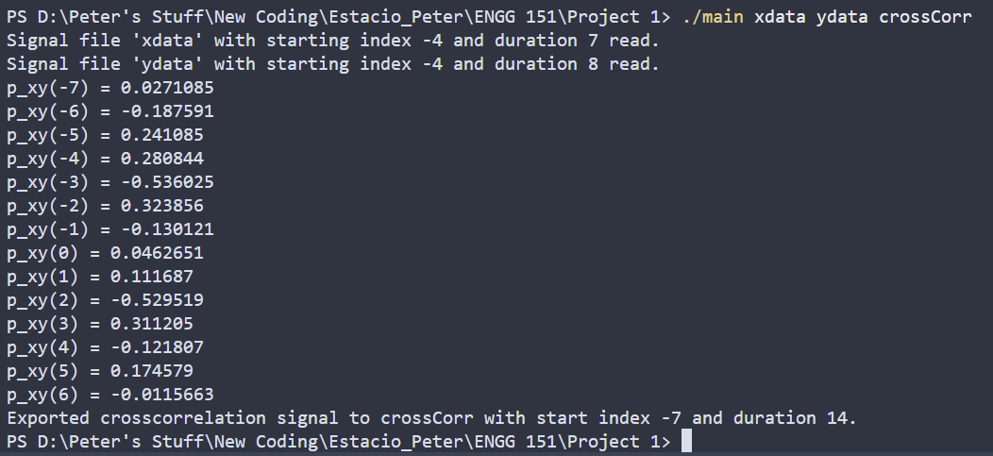
sample screenshot – executable main run and displaying results of main program
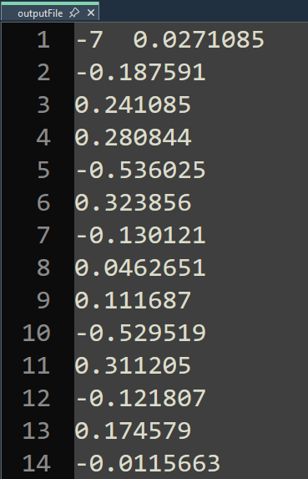
sample screenshot – crosscorrelation signal output to a file named “outputFile”
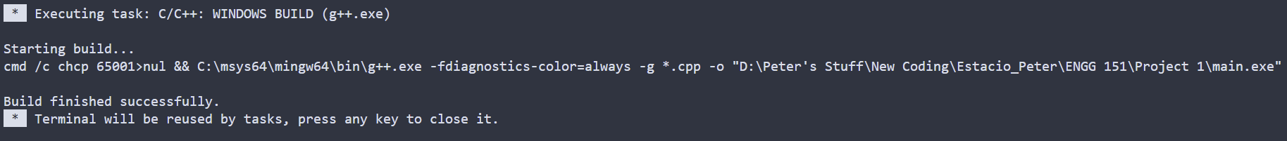
sample screenshot – compilation on Visual Studio Code
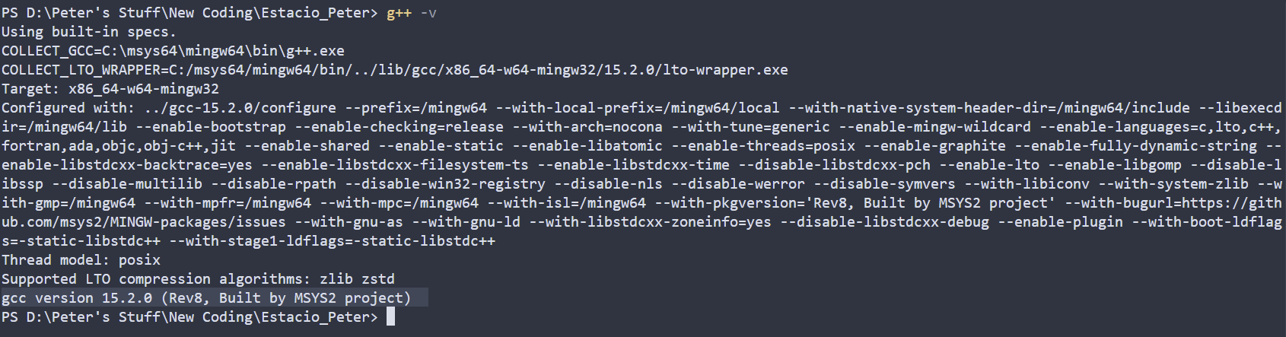
compiler version – gcc version 15.2.0 (Rev8, Built by MSYS2 project)
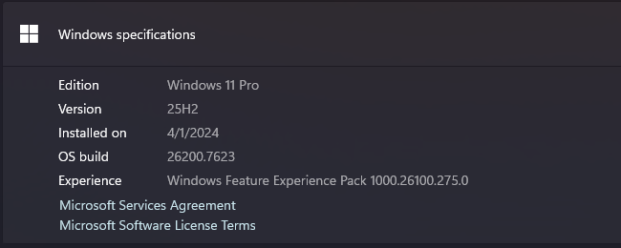
operating system - Windows 11 Pro, 25H2, build 26200.7623
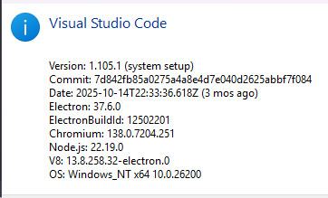
IDE – Visual Studio Code ver 1.105.1

